Team ID : PNT2022TMID48646

Step 1: IBM cloud

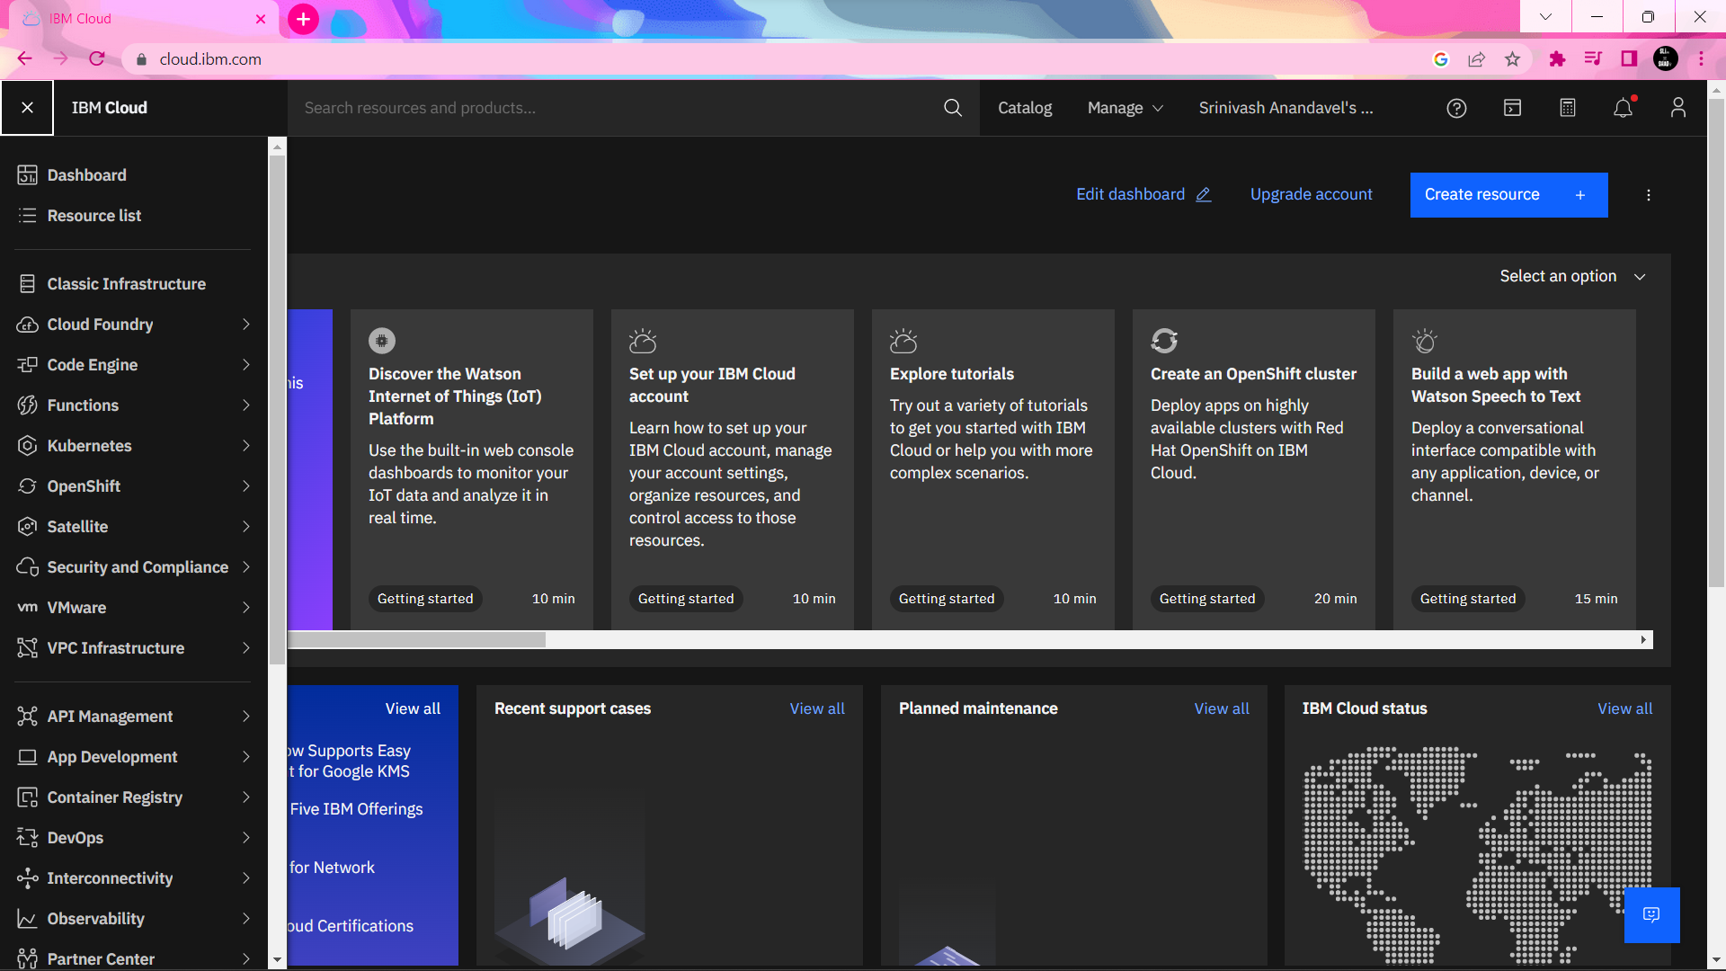

Step 2: Node Red

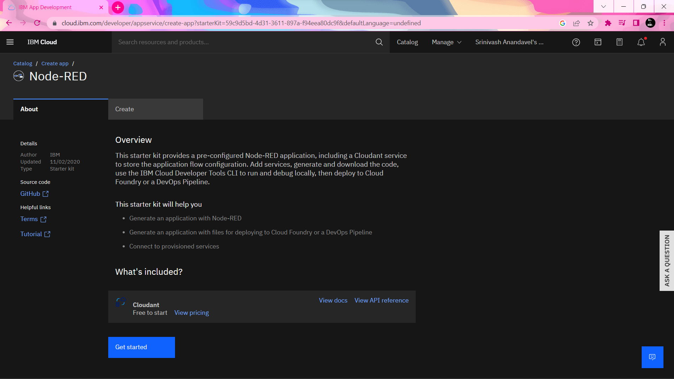

Step 3: IBM Cloudant DB

